**Ride Sharing And CO2 Emissions: A Project Assessment And Proposal For Sustainability**

**Submitted by**

**Dr. Chandrika M**

**Assistant Professor, Department of MCA, DSCE**

**Category:** Cloud Application Development

**Skills Required:**  
Python Web Frame Works, IBM Cloud,Docker/Github,Kubernetes

**Project Description:**

Carbon dioxide (CO2) emissions are a major contributor to climate change and global warming. They are produced by the burning of fossil fuels, such as coal, oil, and natural gas, which are used to power transportation,electricity generation, and other activities.Ride pooling, also known as carpooling, is a form of transportation in which multiple passengers share a ride in a single vehicle. This can help reduce the number of vehicles on the road, which in turn reduces CO2 emissions by reducing the total distance traveled by vehicles. By sharing a ride, passengers can reduce the number of trips taken, which can lead to lower fuel consumption and fewer emissions per person.

Ride pooling can be arranged informally, such as between friends or colleagues, or through organized programs, such as those offered by employers or government agencies. It can also be facilitated through technology, such as smartphone apps, which allow passengers to connect and share rides with others who are traveling along similar routes.In addition to reducing CO2 emissions, ride pooling also has other benefits, such as reducing traffic congestion, improving access to transportation, and reducing the costs of transportation. As a result, it is considered an important strategy for addressing the challenge of reducing emissions from transportation and mitigating the impacts of climate change.

Project requirements:

* A latest system with good internet connection
* HTML, CSS, JS, Bootstrap
* IBM Cloud account
* Python
* Flask
* Docker / Github
* Redhat Openshift / Kubernetes

Project Objectives

* By the end of this project, you will:
* You’ll be able to work with HTML, CSS, JavaScript, and Bootstrap. Build a web application
* Integrate that web application with a Python web framework named FLASK.
* Connect with IBM DB2 for storing the data and Cloud Object Storage for storing the multimedia data.
* Deploying the application in Cloud by making it a container using Docker and managing it with Kubernetes.

**Project Flow**

1. To accomplish this, we have to complete all the activities listed below,
2. Creating User Interface
3. Create a User Interface using HTML, CSS/Bootstrap and JavaScript, where the user will interact and give input.
4. Database Connection
5. Connecting your Application with Database
6. Creating necessary Schemas and Tables
7. Create a Cloud Object Storage to store multimedia data.
8. Flask Application
9. Creating python’s flask web framework to connect the front end with the back end services.
10. Containerization
11. Containerize your application as a docker image and push it into Docker Desktop
12. Creating a Container Registry and pushing the image into the container using Docker Desktop.
13. Kubernetes
14. Creating Kubernetes services and deploying the containerized image into the Kubernetes cluster.
15. Project Structure:

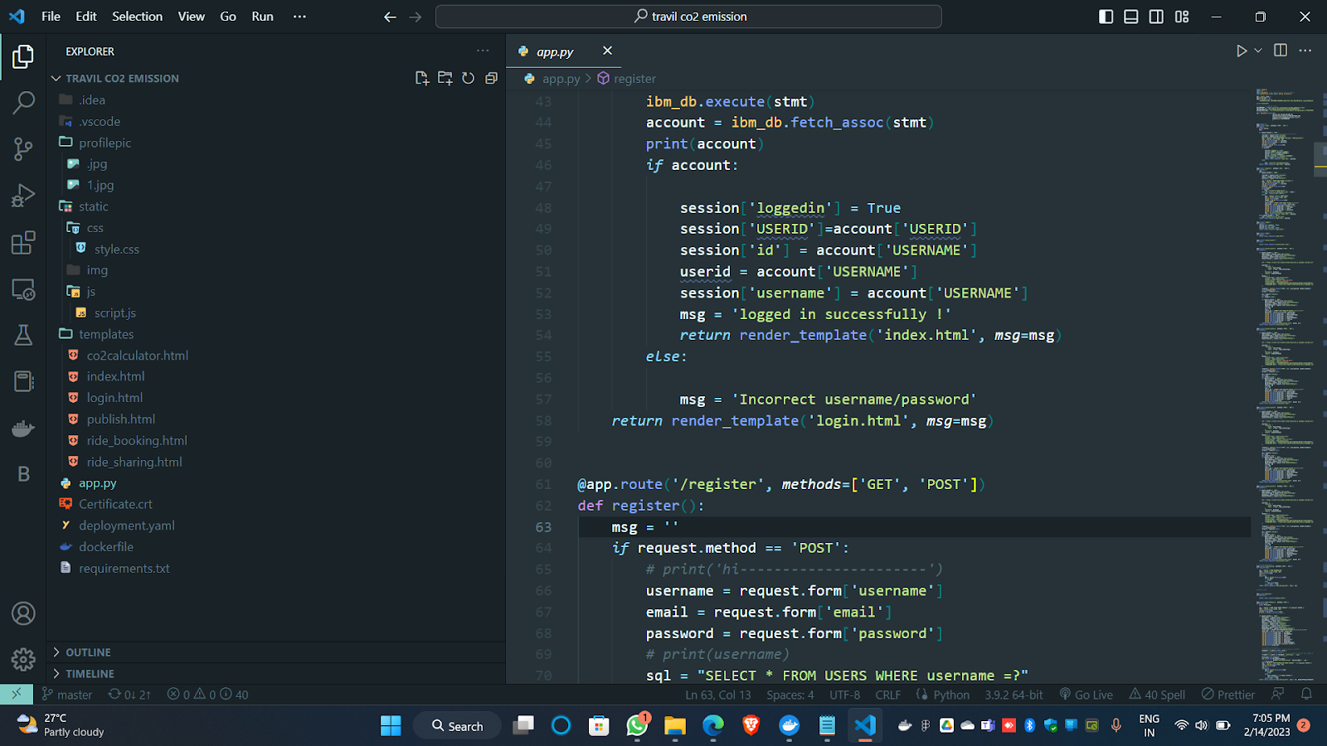

**Some screenshots of the project:**

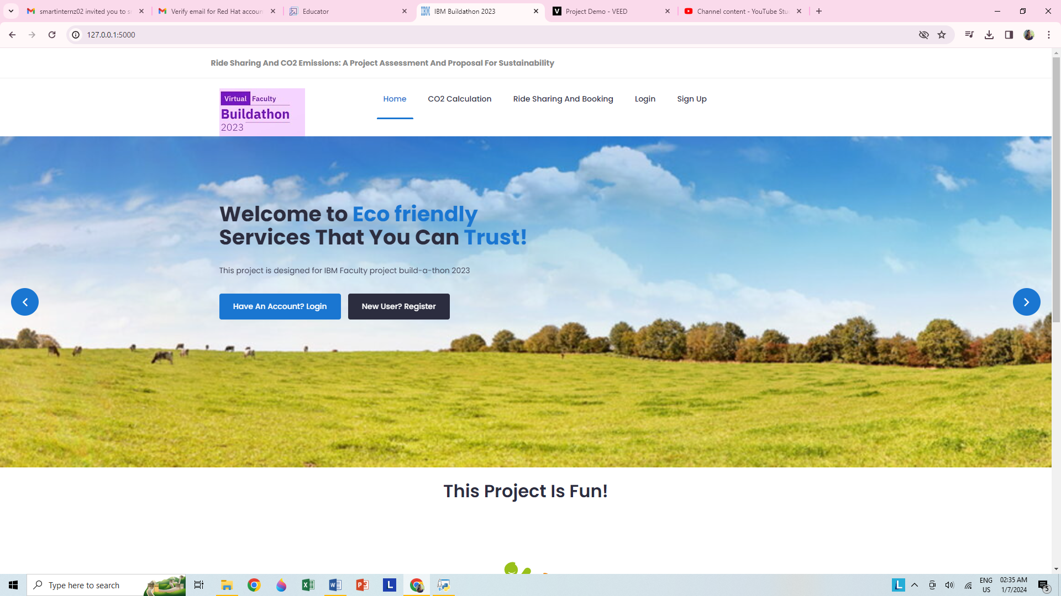

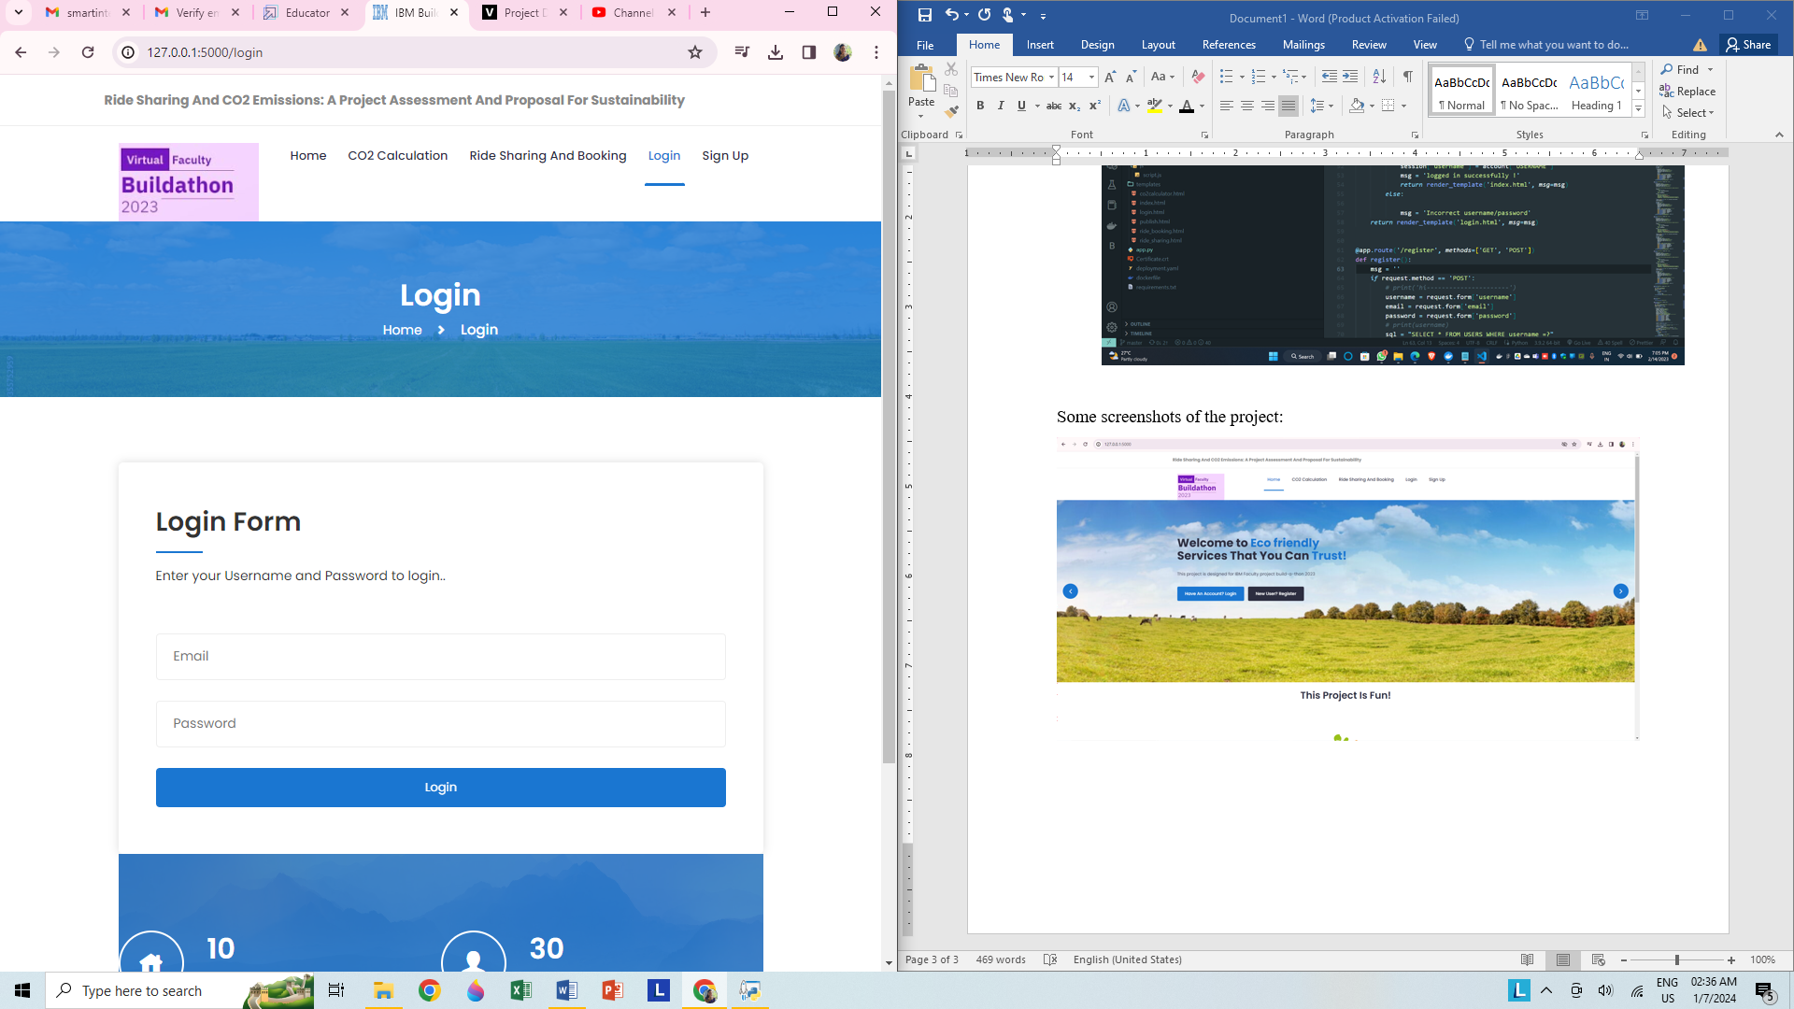 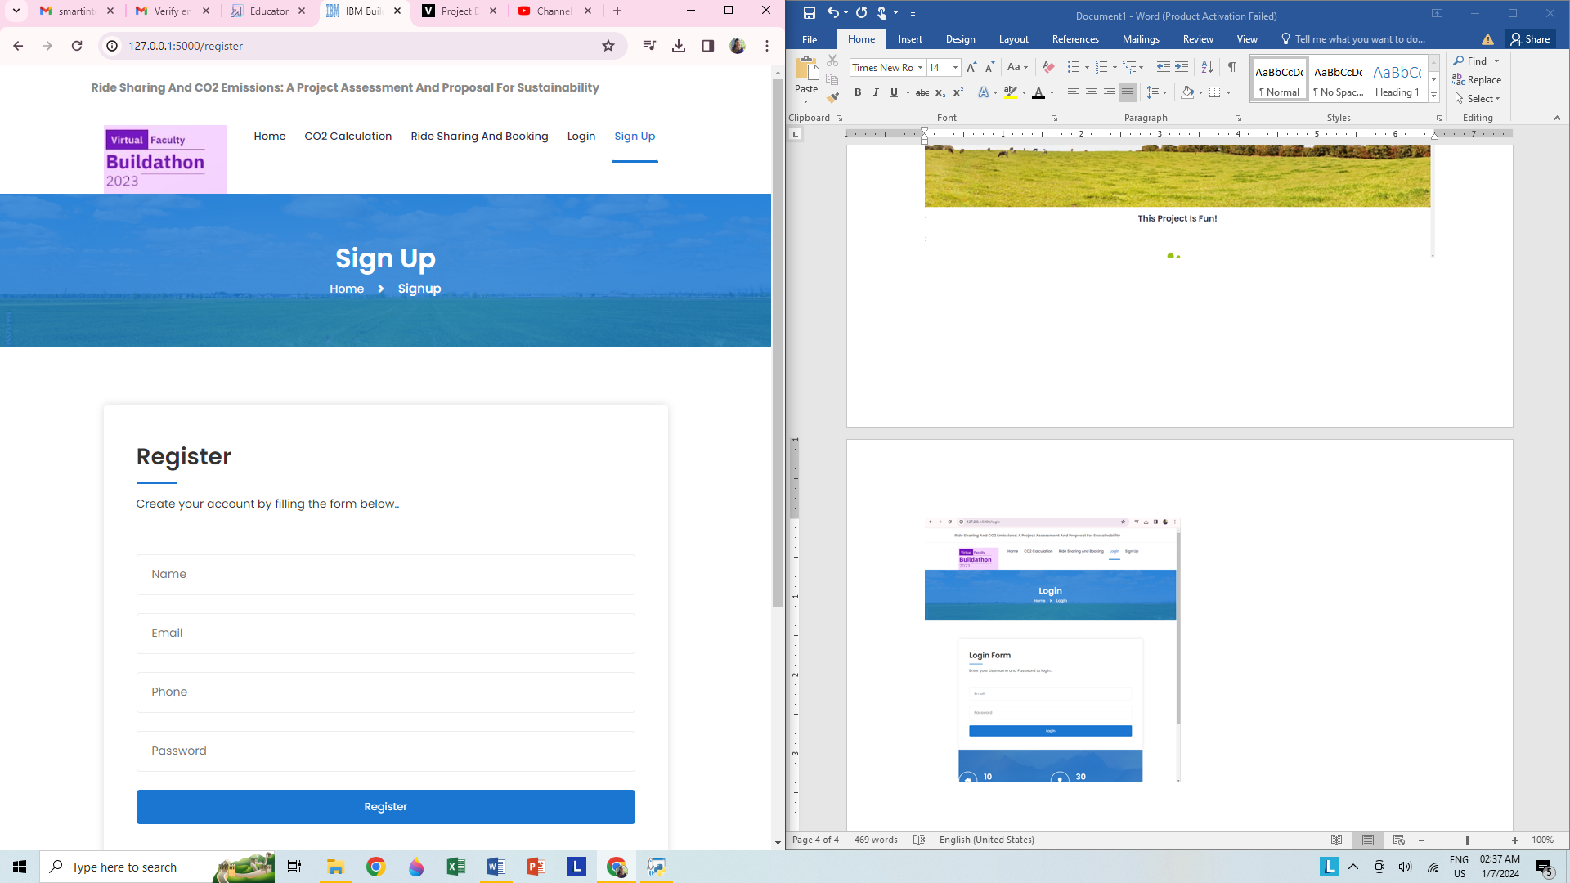

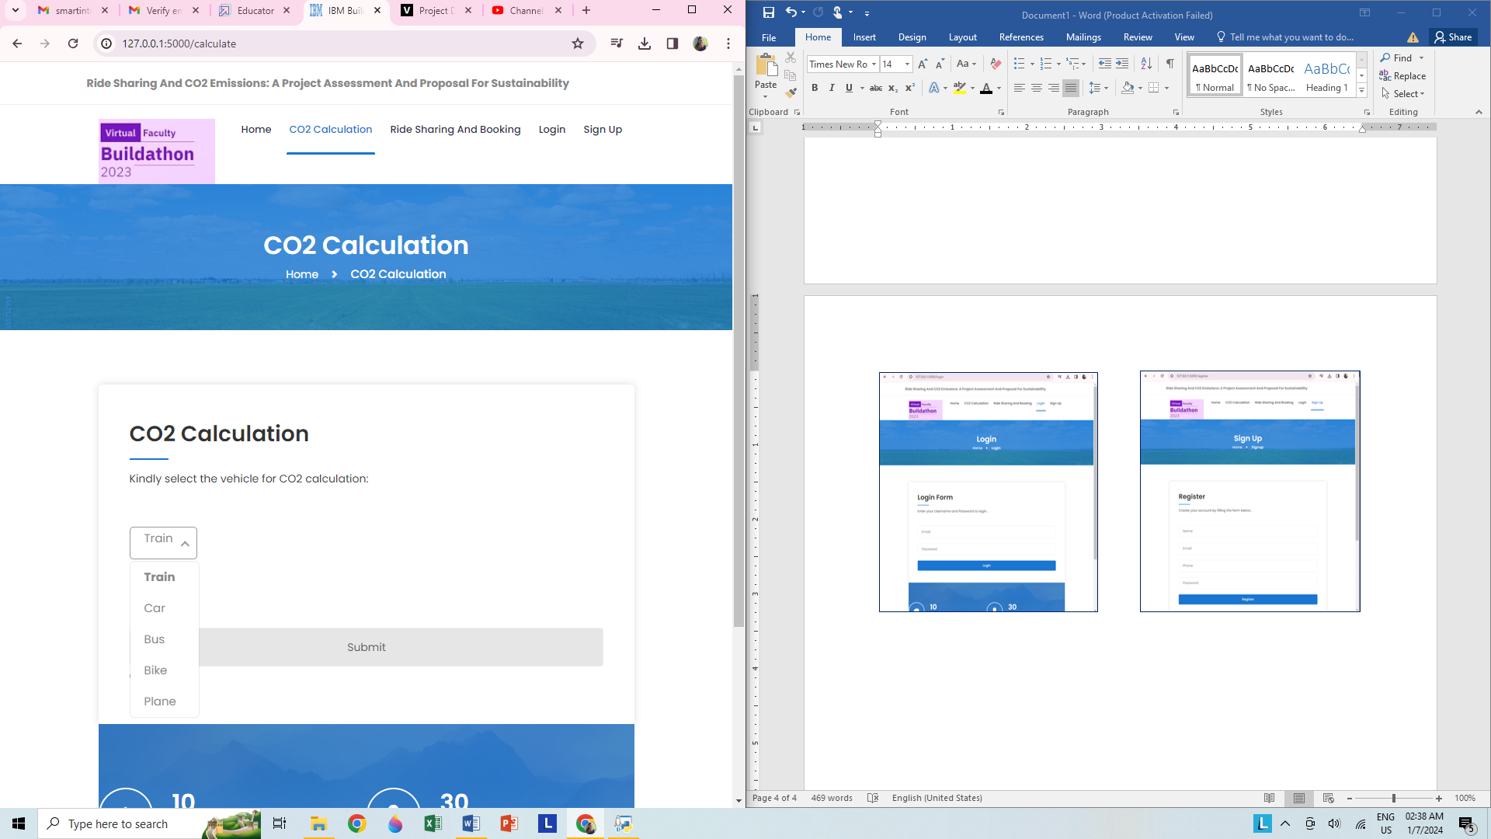 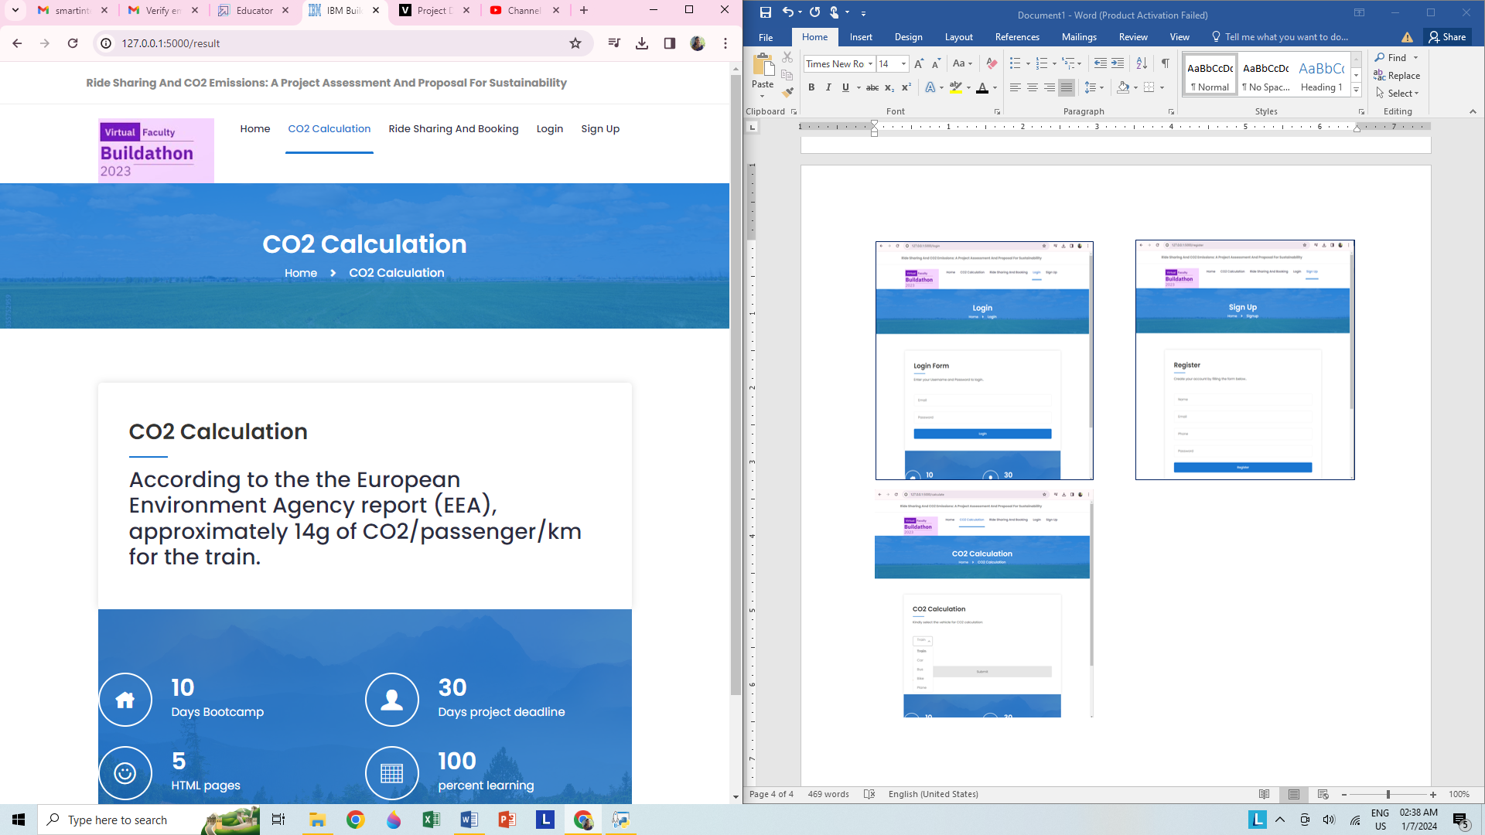

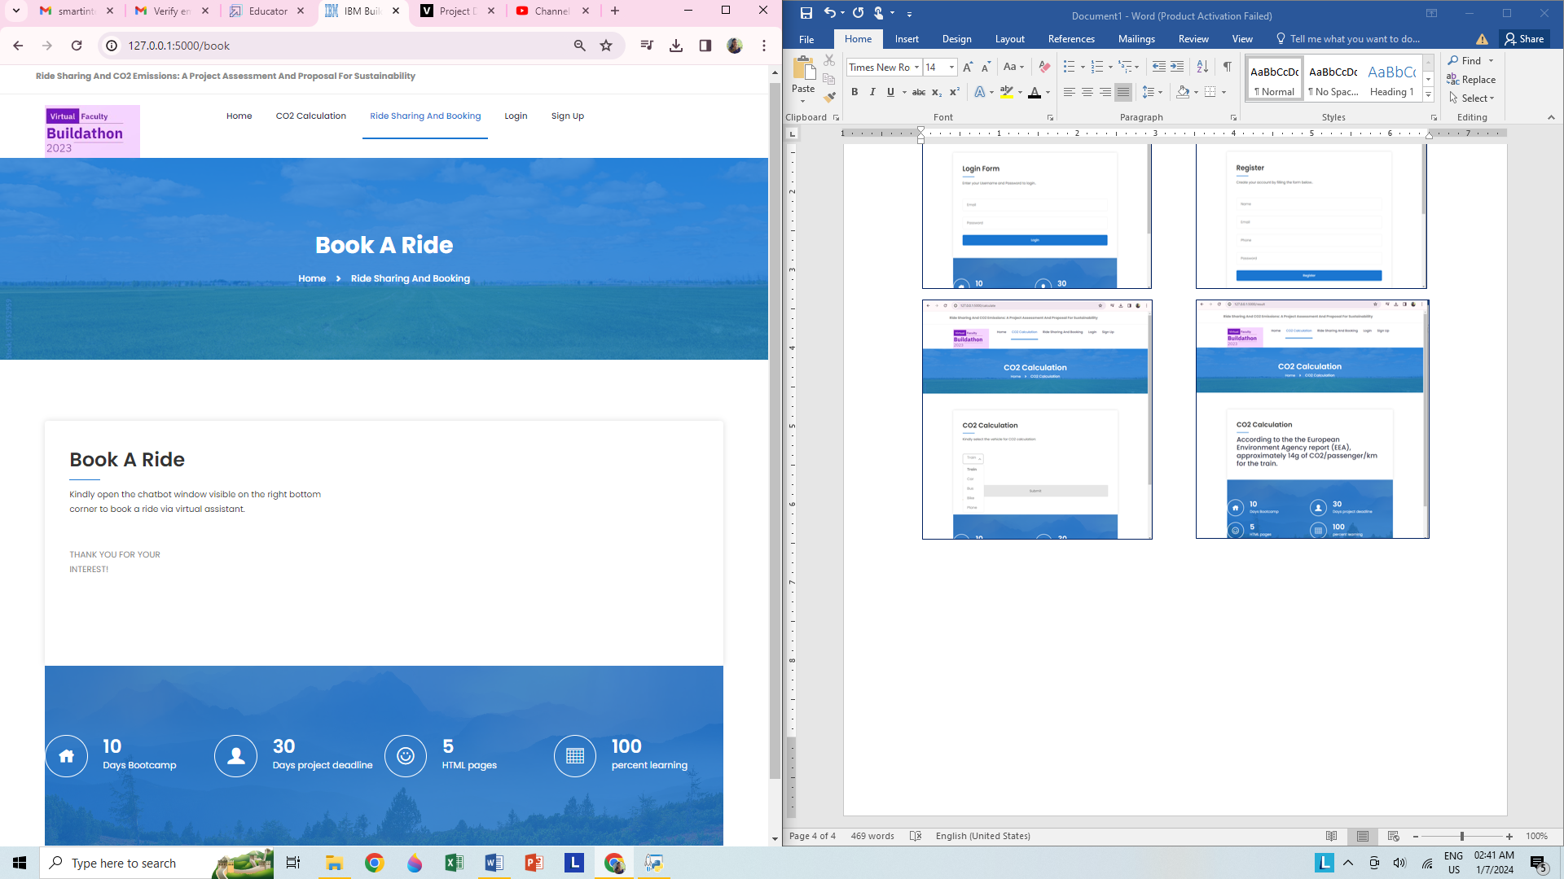

**Github repo link:** <https://github.com/smartinternz02/SI-GuidedProject-659459-1703661356>

**Demo Video Link:** <https://youtu.be/YNMT0yE1st4>

**Redhat deployment url:** <https://youtu.be/YNMT0yE1st4>

**Badge links:**

1. <https://www.credly.com/badges/0c743d6d-12b2-417c-a65c-7a5f2fcac5ac/public_url>
2. <https://www.credly.com/badges/85f64a9b-7d7f-486a-8d00-23c092b1c93a/public_url>
3. <https://www.credly.com/badges/22b82572-1da5-4a15-87ba-9e78bb09b9de/public_url>